
GREEN PRODUCTIVITY ASSOCIATION
Persatuan Produktiviti Hijau Malaysia
(Registration No. 955)
388 Jalan 5/132, Gasing Indah, 46000 Petaling Jaya, Malaysia
Tel: (603) 7783 7696 Fax: (603) 79602194/7783 6572
www.gpam.org.my

SEVENTH ANNUAL GENERAL MEETING
MINUTES OF MEETING

Date: 10 November 2009
Venue: Toh Yuen Chinese Restaurant
Petaling Jaya Hilton
Time: 12.30 pm

Attendance
Dr. Phang Siew Nooi
Mr. Lee Kiyau Loo
Mr. Kuppusamy Singaravelloo
Ms. Chon Wei Fun
Mr. Lim Tuan Chee
Ms Lim Peng Peng
Ms Yap May Lan
Mr. Lim Ka Han
Mr. Lim Tuan Tat
Dr. Beh Loo See

1. President’s Address
  - The President thanked everyone for taking time off to be present at this Seventh Annual General Meeting (AGM) of the Green Productivity Association Malaysia. For a change, the Association decided to have the AGM at the Toh Yuen Chinese Restaurant, PJ Hilton today.

  - The President also announced that the AGM for this year was held later due to unavoidable circumstances as earlier attempts to convene the meeting could not gather the presence of majority of the principal officers or EXCO members of the Association. The meeting noted the explanation given by the President for the delay in calling for this AGM.

2. Confirmation of Minutes of AGM
2.1 Minutes of the last Annual General Meeting of the Association, 2008 which was held on 30 May 2008 was approved by all the members present without amendment.

3. Annual Report
The meeting took note of the Secretary General’s Annual Report for the year under review as follows:

Membership
  - The Association had not received any application to be new members of the Association.

Web-site
  - The meeting noted the urgency in updating the Association’s information. Dr Beh agreed to look at the Association’s web site http://www.gpam.org and see what can be done.

SSCDF
  - The meeting noted the Secretary General had applied for the Service Sector Capacity Development Fund (SSCDF) managed the Malaysian Industrial Development Authority (MIDA), Ministry of International Trade & Industry (MITI) and that a decision would be soon forth coming whether the Association would be given approval or otherwise. If approved, the Association would be required to carry out certain capacity building projects for the service sector. The SSCDF is part of the government’s stimulus package.

Other Projects
  - The Secretary General had also participated in the “Creating Green Value Campaign” and made presentation to secondary school children who visited the ‘Smart Kids 2009′ held at the PWTC (Putra World Trade Centre), Kuala Lumpur from the10th to 12th April 2009.

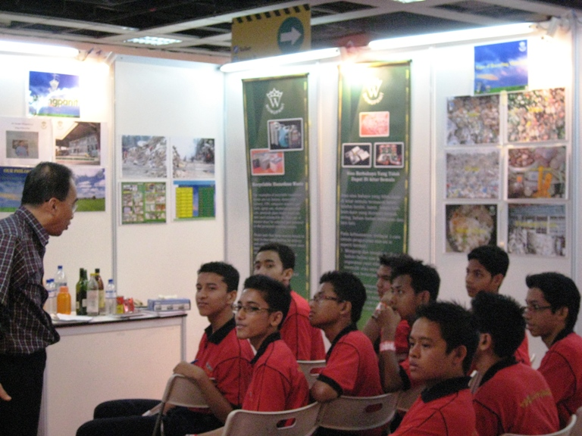

3.5 The Secretary General also reported the possible arrangement with Mr. Christopher Pastakia, a chartered biologist from the UK, to conduct training program in Strategic Environmental Assessment using RIAM (Rapid Impact Assessment Matrix) in the near future. The collaboration details will have to be worked to achieve win-win situation for the Association and the presenter.

4. Financial Report
4.1 The Treasurer tabled the Financial Report; and together with the Internal Auditors’ Report for the Association for the year ending 31 December 2008, with a cash balance of RM7,636.04 was unanimously approved and accepted by the Meeting.

4.2 The Treasurer also raised the issue of large outstanding arrears in uncollected fees, which by this financial year, amounted to RM2,100. A significant proportion of this amount is attributed by corporate members. The meeting requested that these members are given another notice/reminder to collect the outstanding fees and the results to be reported in the next AGM before deciding to relinquish the membership status of the members concerned.

5. Election of Executive Committee for the period 2009-2011
5.1 The following were elected unanimously by the meeting:

President : Dr. Phang Siew Nooi
Deputy President : Dr. Beh Loo See
Secretary General : Mr. Lee Kiyau Loo
Treasurer : Dr. Kuppusamy Singaravelloo
Deputy Secretary General : Ms Lim Peng Peng

Executive Committee : Mr. Lim Tuan Chee
: Ms Yap May Lan
: Mr. Lim Tuan Tat

Internal Auditor
Mr. Lim Ka Han

6. Other Matters
  - There were no other matters raised at the meeting.

The meeting was adjourned at 1.45pm with a vote of thanks to the Chair.

--------------------------------- -------------------------------
Lee Kiyau Loo Dr. Phang Siew Nooi
Secretary General President

File:thumbdrive/MinitAGM2009

